Learning Management System Registrar Job Aid
Contents
Purpose 2
Your Tasks 3
Accessing the Administrative Menu 4
Accessing User Profiles 5
Add a new user profile 6
Edit an existing user profile 10
Assign training role(s) to a user 15
Remove a user’s training role 21
Email login id and password to a user 24
Delete a user 26
Look up Registrars 29
Manage Certified Investigator Emails 32
Manage Certification Types for Certified Investigators 46

Purpose

The Home and Community Services Information System (HCSIS) project is using a Learning Management System (LMS) to assist in training logistics, including registration and tracking attendance. User profiles include all contact and location information, the user’s login id and password and the user’s training roles.

Job Aid Organization
This job aid is organized with the following subsection:
- Your Tasks: The Tasks section outlines the steps necessary to complete this job aid. In addition, this section identifies the HCSIS screens used to complete the tasks.

Your Tasks

As a registrar, you can perform the following tasks:
Task | Page Number
Access the Admin Menu | Error: Reference source not found
Access the user profiles | 5
Add a new user profile | 6
Edit an existing user profile | 10
Assign training role(s) to a user | Error: Reference source not found
Remove a user’s training role | Error: Reference source not found
Email login id and password to a user | 24
Delete a user | 26
Look up Registrars | 29
Manage Certified Investigator Emails | 32
Manage Certification Types for Certified Investigators | 46

Detailed instructions are included in this job aid packet. The documentation for each task is divided into the following sections:
Section | Use
Procedure Description | This is a brief summary of the purpose of the screen. It includes the context of this screen within the process.
Dependencies | The steps that precede the start of a procedure.
Steps | This describes the steps for completing the procedure.

Accessing the Administrative Menu

Procedure Description

Use this screen to access the Admin Menu.
Dependencies
- You will not have access to the Admin Menu until the System Administrator has assigned you the security role of Registrar.
- You must log onto the LMS in the following location: www.humanservices-r.state.pa.us/hcsislms
Steps
- Choose the “Admin Menu” link.

NOTE: Click on the link on the left menu or the top menu bar to access the Administrative Menu. If the Admin Menu is not displaying on the left menu bar, click on the plus (+) sign next to LMS Admin.

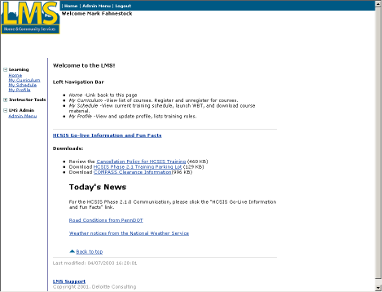

Accessing User Profiles

Procedure Description

After you select Admin Menu, the LMS displays the Admin Menu with a link to Users.
Dependencies
- Access this screen by clicking the “Admin Menu” link
- You must select one of the Admin Menu links.

Steps
- Choose the “Users” link.

Add a new user profile

Procedure Description

After you select the “Users” link, the User Profiles page displays with a link to add a new user.
Dependency
- You must click “Users” from the Admin Menu to access this page.

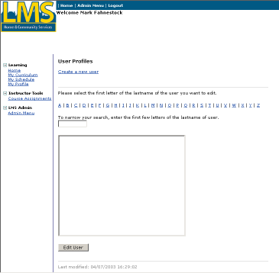
Steps
- Choose the “Create a new user” link
Add a new user profile (Continued)

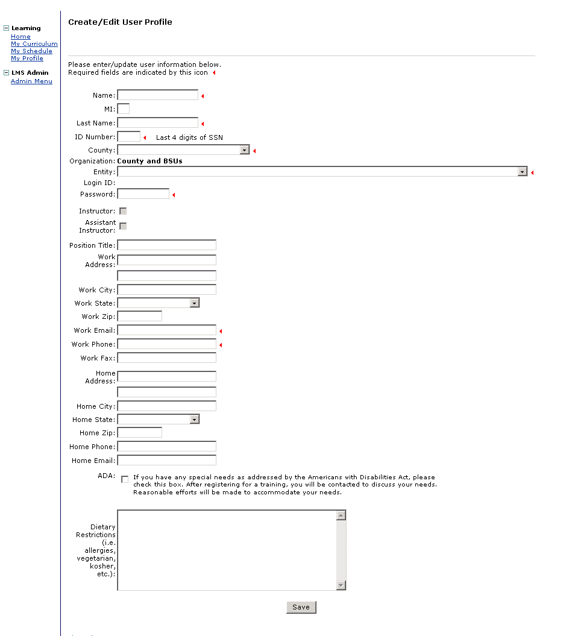
Add a new user profile (Continued)
- On the “Create/Edit” User Profile” screen, complete the following fields:

Note: Mandatory fields must have values. Optional fields may be blank.
Field Name | Description
Name | Mandatory. Enter user’s first name.
MI | Optional. Enter user’s middle initial.
Last name | Mandatory. Enter user’s last name.
ID Number | Mandatory. Enter the last 4 digits of user’s social security number.
County | Mandatory: Select the user’s county.
Entity | Mandatory. Select the user’s entity. For example, if you are a County or BSU registrar, select the user’s county or BSU from the list. The entities in the list are determined by your organization.
Password | Mandatory. Enter a password.
Position Title | Optional. Enter user’s job title.
Work Address | Optional. Enter user’s primary work street address.
Work City | Optional. Enter user’s primary work city address.
Work State | Optional. Enter PA.
Work Zip | Optional. Enter the zip code for user’s primary work address.
Work Email | Mandatory. Enter user’s email address.
Work Phone | Mandatory. Enter user’s work phone number.
Work Fax | Optional. Enter user’s fax number.
Home Address | Optional. Enter user’s primary home street address.
Home City | Optional. Enter user’s primary home city address.
Home State | Optional. Enter PA.
Home Zip | Optional. Enter the zip code for user’s primary home address.
Home Phone | Optional. Enter user’s home phone number.
Home Email | Optional. Enter user’s email address.
ADA | Optional: Check this box if the user has any special needs as addressed by the Americans with Disabilities Act.
Dietary Restrictions | Optional: Enter any special dietary requests. This box can also be used to enter any notes pertaining to the user.
- Click “Save”.
- To prevent entry of duplicate user profiles the system performs several tests. If the entries do not pass the tests, you will be prompted to contact the HCSIS Help Desk. The tests are:
- The login id cannot already exist in the LMS
- The combination of last name and email cannot already exist in the LMS.
- The combination of first name and last name cannot already exist in the LMS
- If the new profile passes all tests, the system will generate a login id using the user’s initials and SSN.

NOTE: The LMS will send an email message within 24 hours to the email account you specified with the user id and password.

Edit an existing user profile

Procedure Description

After you select the “Users” link, this page displays.
Dependency
- You must click “Users” from the Admin Menu to access this page.

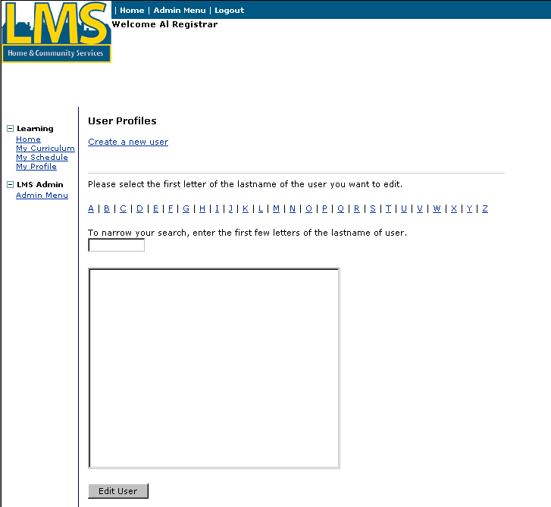
Steps
- Select the link for the first letter of the last name of the user whose profile you wish to edit. The LMS populates the list box with users from your organization whose last name begins with the letter you selected.
Edit an existing user profile (Continued)
- Enter the first few letters of the last name of the user whose profile you wish to edit in the box provided. As the letters are entered, the list box displays only the users that match your search.
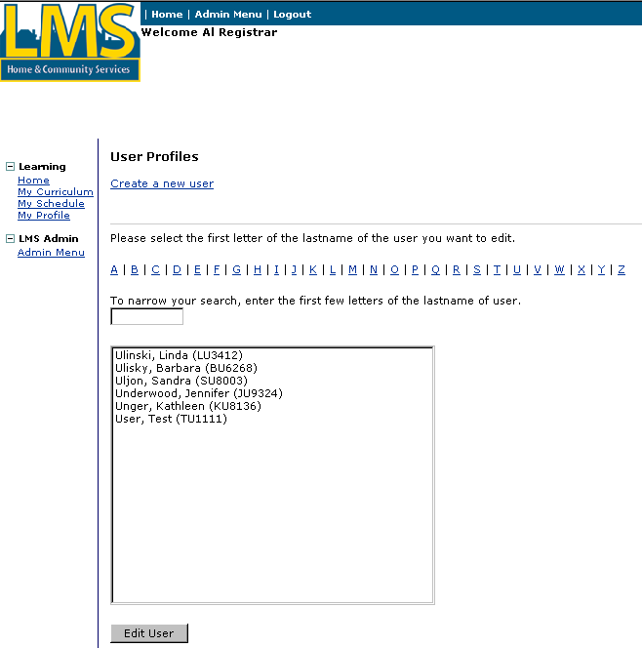
- Alternatively, you can scroll through the list box until you find the name of the user that you want to edit.

NOTE: If you are using a browser other than Internet Explorer, you will not see the box to enter the first few letters of the name. You will have to scroll through the list.
- Click on the user in the list box and then click on the “Edit User” button.
Edit an existing user profile (continued)

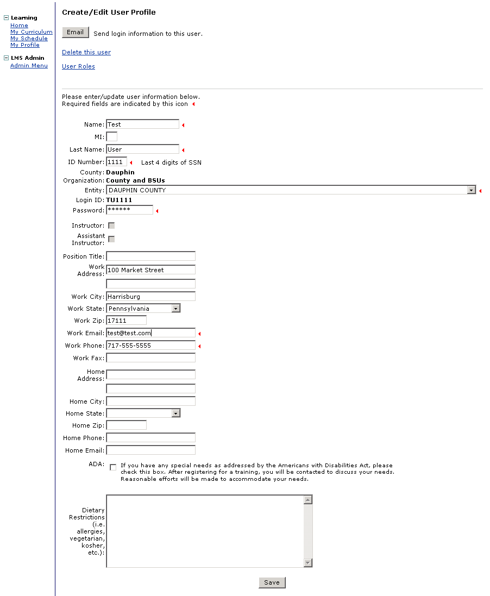
Edit an existing user profile (continued)
- On the “Create/Edit User Profile screen, complete the following fields:

Note: Mandatory fields must have values. Optional fields may be blank.
Field Name | Description
Name | Mandatory. Enter user’s first name.
MI | Optional. Enter user’s middle initial.
Last name | Mandatory. Enter user’s last name.
ID Number | Mandatory. Enter the last 4 digits of user’s social security number.
Entity | Mandatory. Select the user’s entity. For example, if you are a County or BSU registrar, select the user’s county or BSU from the list. The entities in the list are determined by your organization.
Password | Mandatory. Enter a password.
Position Title | Optional. Enter user’s job title.
Work Address | Optional. Enter user’s primary work street address.
Work City | Optional. Enter user’s primary work city address.
Work State | Optional. Enter PA.
Work Zip | Optional. Enter the zip code for user’s primary work address.
Work Email | Mandatory. Enter user’s email address.
Work Phone | Mandatory. Enter user’s work phone number.
Work Fax | Optional. Enter user’s fax number.
Home Address | Optional. Enter user’s primary home street address.
Home City | Optional. Enter user’s primary home city address.
Home State | Optional. Enter PA.
Home Zip | Optional. Enter the zip code for user’s primary home address.
Home Phone | Optional. Enter user’s home phone number.
Home Email | Optional. Enter user’s email address.
ADA | Optional: Check this box if the user has any special needs as addressed by the Americans with Disabilities Act.
Dietary Restrictions | Optional: Enter any special dietary requests. This box can also be used to enter any notes pertaining to the user.
- Click “Save”.

Assign training role(s) to a user

Procedure Description

Select an existing user. Select training role(s) from a list and assign the role(s) to the user.
Dependencies
- Select “Users” from the Admin Menu.
- Select the link for the first letter of the last name of the user whose profile you wish to edit. The LMS populates the list box with users from your organization whose last name starts with the letter you selected.
- Enter the first few letters of the last name in the box provided. As the letters are entered, the list box displays only the users that match your search.
- Alternatively, scroll through the list box for the user’s name. If you are NOT using Internet Explorer, the box to enter the first few letters of the last name will not display.
- Select a user and then click on “Edit User”. The LMS displays the selected user profile.
Assign training roles(s) to a user (continued)

The selected user’s profile displays.
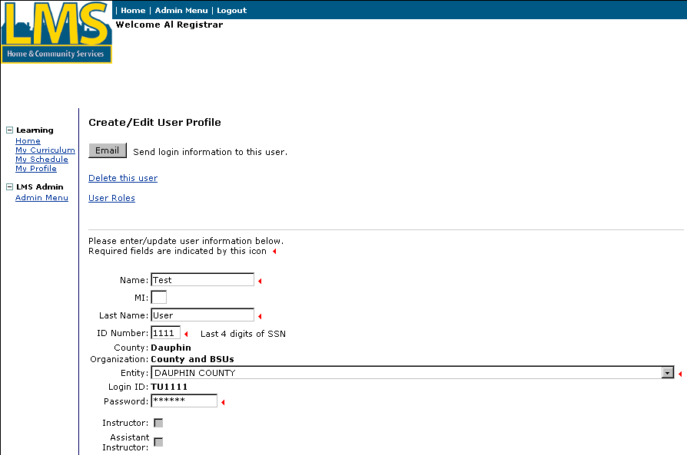

Steps
- To move to the user roles section of the user profile page, click on the “User Roles” link at the top of the page.
Assign training role(s) to a user (continued)

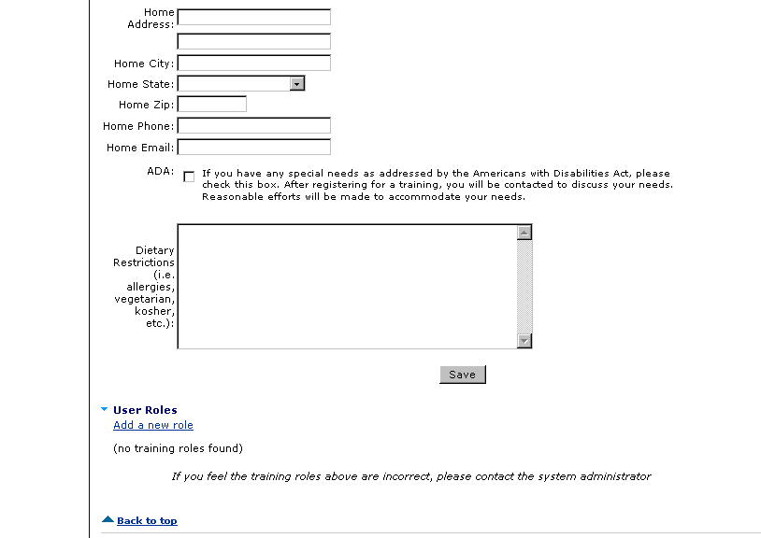
- Click on the “Add a new role” link.
Assign training role(s) to a user (continued)

The Assign Training Role(s) to a User page displays. Training roles that have not been assigned to the selected user are listed in the Training roles list box.
- Select a role from the Training roles list.
- Click the right arrow [→] button to move the roles to the Assign roles list box.
Assign training role(s) to a user (continued)

The role you selected displays in the Assign roles list box.
Tip: If you have moved a role to the Assign roles list box in error, select the role in the Assign roles box and click the left arrow [←] to remove it.
- Repeat Steps 3 and 4 to assign more training roles to the user.
- Click the “Assign Roles” button.
Assign training role(s) to a user (continued)

The user’s profile displays with the assigned training roles listed under “user roles” at the bottom of the page.

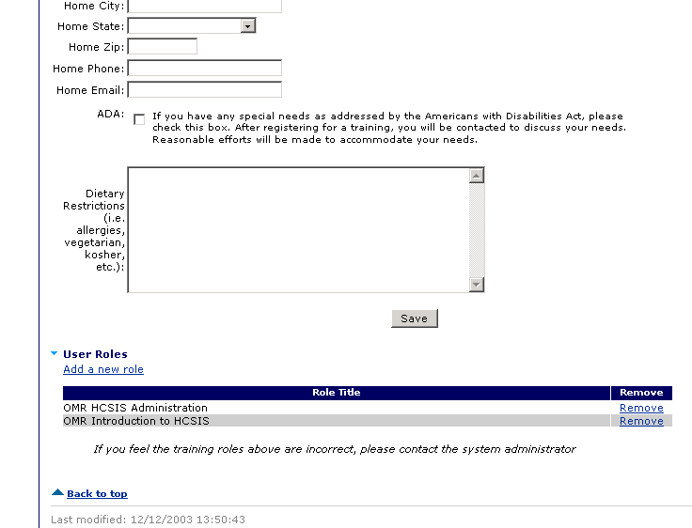
- Click “Save” to save settings and return to the “Select User Profile” page.

Remove a user’s training role

Procedure Description

Select an existing user. Select a training role that has been assigned to a user and remove it.
Dependencies
- Select “Users” from the Admin Menu.
- Select the link for the first letter of the last name of the user whose profile you wish to edit. The list box will display the users from your organization with the last names you selected.
- Enter the first few letters of the last name in the box provided. As the letters are entered, the list box displays only the users that match your search.
- Alternatively, scroll through the list box for the user’s name. If you are NOT using Internet Explorer, the box to enter the first few letters of the last name will not display.
- Select a user and then click on “Edit User”. The LMS displays the selected user profile.
Remove a user’s training role (continued)

Steps
- To move to the user roles section of the user profile page, click on the “User Roles” link at the top of the page.
Remove a user’s training role (continued)
- Click on the “Remove” link for the training role that you wish to remove. A confirmation box will display.

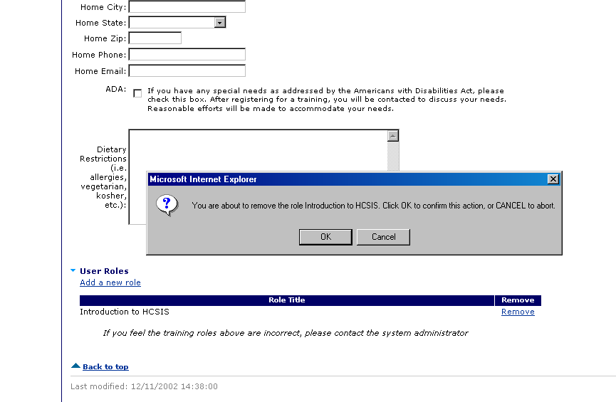
- Click on “OK” to confirm removal of the training role.
- The user’s profile will display with the selected training role removed from the list.
- Click “Save” to save settings and return to the “Select User Profile” page.

Email login id and password to a user

Procedure Description

Select an existing user. Send an email to the user with his or her login id and password.
Dependencies
- Select “Users” from the Admin Menu.
- Select the link for the first letter of the last name of the user whose profile you wish to edit. The list box will display the users from your organization with the last names you selected.
- Enter the first few letters of the last name in the box provided. As the letters are entered, the list box displays only the users that match your search.
- Alternatively, scroll through the list box for the user’s name. If you are NOT using Internet Explorer, the box to enter the first few letters of the last name will not display.
- Select a user and then click on “Edit User”. The LMS displays the selected user profile.
Email login id and password to a user (continued)

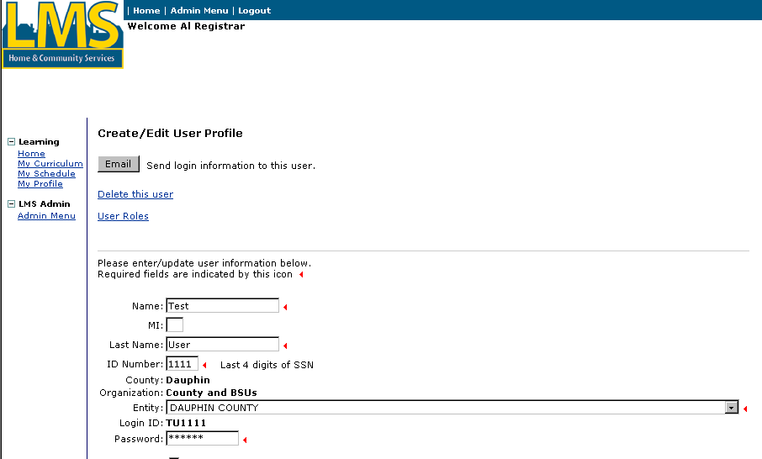

Steps
- Click on the “Email” button at the top of the profile.
- If the email was successfully sent, a confirmation message will display above the “Email” button.

Delete a user

Procedure Description

Select an existing user. Delete the user.
Dependencies
- Select “Users” from the Admin Menu.
- Select the link for the first letter of the last name of the user whose profile you wish to edit. The list box will display the users from your organization with the last names you selected.
- Enter the first few letters of the last name in the box provided. As the letters are entered, the list box displays only the users that match your search.
- Alternatively, scroll through the list box for the user’s name. If you are NOT using Internet Explorer, the box to enter the first few letters of the last name will not display.
- Select a user and then click on “Edit User”. The LMS displays the selected user profile.
Delete a user (continued)

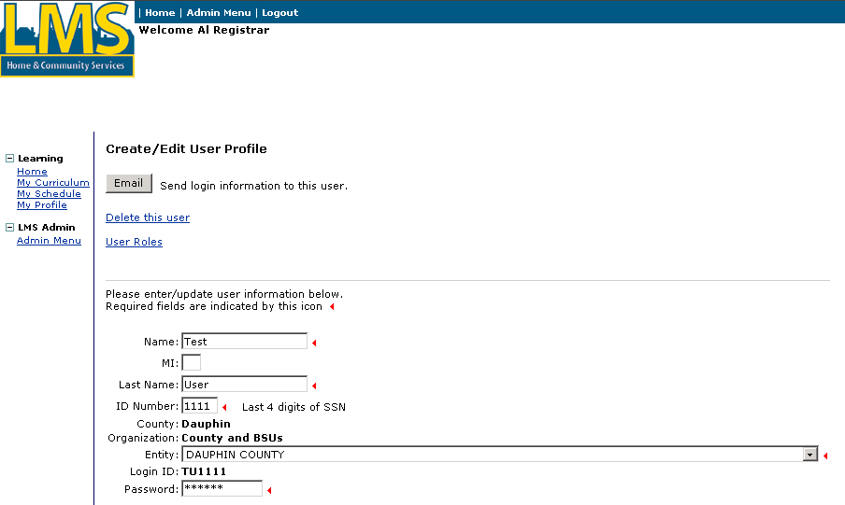

Steps
- Click on the “Delete this user” link at the top of the profile.
Delete a user (continued)
- A confirmation will display. Click on the “OK” button to delete the user. The system will delete the user and return to the “Select User Profile” page.

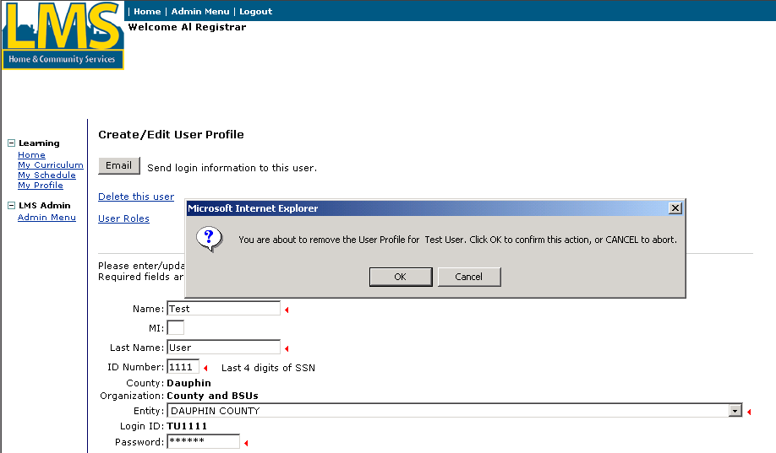

Look up Registrars

Procedure Description

Look up a Registrar for an entity.
Dependencies
- Select “Admin Menu”
- Select “Registrars” from the Admin Menu.
Look up Registrars (continued)

The “LMS Registrars” page displays:

Steps
- Select an Organization from the list.
- Select an Entity from the list.
Look up Registrars (continued)

The LMS displays contact information for the Registrar(s) associated with the entity you selected.

Manage Certified Investigator Emails

Procedure Description

IMPORTANT: Deleting or adding email messages should only be done under the direction of the database developer.

Email text used in messages sent out to users is managed from the Letters link on the Certified Investigator menu located on the Admin Menu. Some emails such as course confirmations, course reminders and notification of certification expiration are sent out every day during off peak hours by the automated server. Certified Investigator instructors send out certification status emails as part of the attendance update for certification courses and exams and re-certification courses.

The email message text is incorporated in an automated procedure on the database server so it is extremely important that any changes are verified with the database developer. Deleting a message or changing the name of a message can result in the failure of disseminating important information to users.

NOTE: When you delete an email message, it is physically deleted from the database and cannot be retrieved. A message that is deleted in error must be recreated.

The email message includes:
- The name of the email.
- The training type of the email.
- The description of the email.
- The section of the email, for example, subject, header, body.
- The text of the message.
- The certification type associated with the email (for example, Pennsylvania Certified Investigators Exam, PA Certified Investigators Exam Pennsylvania Re-certification Course, non-certification courses)

This procedure describes the methods for adding and editing an email message. It also describes the methods for adding and editing a section and text to the email.
Manage Certified Investigator Emails (continued)

Add an email type
Dependencies
- Log into the LMS.
- Click the “Admin Menu” link.
Steps
- Click “Letters”.
Manage Certified Investigator Emails (continued)

Add an email type (continued)

The list of emails for the training type displays.
- Click “Create an email”.
Manage Certified Investigator Emails (continued)

Add an email type (continued)

The Enter or Edit Email Type page displays.
Tip: To return to the Email List without saving changes, click the Return to Email List link.
IMPORTANT: Verify the email name with the database developer.
IMPORTANT: An email must be created for each certification type. For example, there must be two separate COURSE_EXAM_CONFIRM emails, one for PA Certified Investigator Exam and one for Pennsylvania Certified Investigator Exam.
- Complete the following fields:

NOTE: Mandatory fields must have values. Optional fields may be blank.
Field Name | Description
Email Name | Mandatory. Enter a name for the email.
Description | Optional: Enter a description of the email’s purpose.
Certification Type | Mandatory: Choose the certification type
- Click [Save].
Manage Certified Investigator Emails (continued)

Add an email type (continued)

The new email type is saved and the Emails by Training Type page displays again, this time with the new email on the list.
Manage Certified Investigator Emails (continued)

Edit an email type
Dependencies
- Log into the LMS.
- Click the “Admin Menu” link.
- Click “Letters” link under Certified Investigator Setup
Steps
- Click the “Edit” link for the email type that you want to edit.
Manage Certified Investigator Emails (continued)

Edit an email type (continued)
Tip: To return to the Email List without saving changes, click the Return to Email List link.

The Enter or Edit Email Type page displays.
IMPORTANT: Verify the email name with the database developer.
IMPORTANT: An email must be created for each certification type. For example, there must be two separate COURSE_EXAM_CONFIRM emails, one for PA Certified Investigator Exam and one for Pennsylvania Certified Investigator Exam.
- Edit one or all of the following fields:

NOTE: Mandatory fields must have values. Optional fields may be blank.

Field Name | Description
Email Name | Mandatory. Enter a name for the email. IMPORTANT: Verify name modifications with the database developer.
Description | Optional: Enter a description of the email’s purpose.
Certification Type | Mandatory. Select the certification type.
- Click [Save].
Manage Certified Investigator Emails (continued)

Edit an email type (continued)

The changes are saved and the Emails by Training Type page displays again.
Manage Certified Investigator Emails (continued)

Add an email message section to an email type
Dependencies
- Log into the LMS.
- Click the “Admin Menu” link.
- Click the “Letters” link under Certified Investigators Setup.
Steps
- Click the “Edit” link for the email type that you want to edit.
Manage Certified Investigator Emails (continued)

Add an email message section to an email type (continued)

The Enter or Edit Email Type page displays.
- Click the “Create new message text” link.
Manage Certified Investigator Emails (continued)

Add an email message section to an email type (continued)

The Enter or Edit Email Message page displays.
- Complete the following fields:

NOTE: Mandatory fields must have values. Optional fields may be blank.
Field Name | Description
Email Text | Mandatory. Enter the text to be included in the email.
Section | Mandatory: Select the section.
- Click [Save].
Manage Certified Investigator Emails (continued)

Add an email message section to an email type (continued)

The Enter or Edit Email Type Information page displays again with the message section listed.
- To add another section to the email, repeat steps 4 through 6.
- To edit a section message click the associated “Edit” link and repeat steps 5 and 6.
Manage Certified Investigator Emails (continued)

Add an email message section to an email type (continued)

To view the layout of the email message, select the “View Email Message Layout” link.
Manage Certified Investigator Emails (continued)

Add an email message section to an email type (continued)

The Email Message Layout window opens. It displays the text from the message sections with a placeholder for the context specific information that is generated when the email is sent.
Tip: To close the window and return to the Email Type Information page, use the window close button.

Manage Certification Types for Certified Investigators

Procedure Description

Certification types track management information such as requirements for certification, number of years of certification, certificate text, etc.

Some settings such as length of certification and recertification notice are used to determine when users receive emails pertinent to their certification status.

Other settings such as required score and number of retries indicate whether there is an exam associated with the course, the passing score and the number of times applicants can retake an exam before having to retake the associated course.

NOTE: A certification management record is created for each certification course or certification course/exam combination. Do not create a certification management record for a non-certification course such as Evaluation of the Quality of Investigations.
Manage Certification Types for Certified Investigators (continued)

Edit a certification type
Dependencies
- Log into the LMS.
- Click the “Admin Menu” link.
- Click “Setup” under Certified Investigator Setup

The Certified Investigator Management screen displays with the list of types.
Tip: To create a new certification type click the “Create a new certification type” link and enter the data described on page 47.

Steps
- Click “Edit” link for the record that you want to change.
Manage Certification Types for Certified Investigators (continued)

Edit a certification type (continued)

The Create/Edit Investigator Management screen displays.
Tip: To return to the Certification type list without saving changes, click the Return to CI Management List link.
Manage Certification Types for Certified Investigators (continued)

Edit a certification type (continued)
- On the “Create/Edit Certified Investigator Management” screen, complete the following fields:

Note: Mandatory fields must have values in order to save changes.
Field Name | Description
Existing Entries | Mandatory. Select the certification entry from the drop down box. When you choose an existing entry, the following fields will be pre-populated and can be edited as necessary.
Name | Mandatory. Enter the name of the certification information.
Course Exam | Mandatory. Select the name of the exam from the drop down box that is required for the certification.
Role | Mandatory. Select the role from the drop down box that the candidate will acquire once they are certified.
Required Score | Mandatory. Enter the minimum score required to pass the exam in order to become certified.
Exam Retries | Mandatory. Enter the number of times a candidate can take the exam until they must re-register for the certification course.
Length of Certification | Mandatory. Enter the number of months the certification is valid.
Recertification Notice | Mandatory. Enter the number of months prior to certification expiration. The Certified Investigator will be notified with a recertification letter that they must take the course again in order to stay certified.
Certificate Header | Mandatory: Enter the text to be printed at the top of the certificate for successful applicants.
Certificate Body | Mandatory: Enter the text to be printed in the body of the certificate for successful applicants.

- Click “Save” to save changes.

You have completed this Job Aid.

